**Lab 1**

Jiho Kim, Garth Slaney

ENSF 480

Submission Date: September 24, 2020

University of Calgary

**Answer the questions in Exercise A in the following table and post it into the D2L**

|  |  |
| --- | --- |
| **Program output and its order** | **Your explanation (why and where is the cause for this output)** |
| **constructor with int argument is called.** | it is called at line 12 in exAmain. The statement, Mystring c = 3is interpretedby the compiler as a call to theconstructor Mystring::Mystring(int n). |
| **default constructor is called.**  **default constructor is called.** | It is called in line 18 in exAmain. The statement, Mystring x[2] is interpreted by the compiler as two calls to the default constructor Mystring::Mystring(). |
| **constructor with char* argument is called.** | It is called in line 22 in exAmain. The statement, Mystring* z = new Mystring("4") is interpreted by the compiler as a call to Mystring::Mystring(const char *s). |
| **copy constructor is called.**  **copy constructor is called.** | It is called in line 24 in exAmain. The statement, x[0].append(*z).append(x[1]) is interpreted by the complier as two calls to Mystring::Mystring(const Mystring& source) to copy the arguments need for Mystring& Mystring::append(const Mystring other). |
| **destructor is called.**  **destructor is called.** | It is called in line 24 in exAmain. The statement, x[0].append(*z).append(x[1]) is interpreted by the complier as two calls to Mystring::~Mystring() to destroy the arguments for Mystring& Mystring::append(const Mystring other). |
| **copy constructor is called.** | It is called in line 26 in exAmain. The statement Mystring mars = x[0] is interpreted by the compiler as a call to Mystring::Mystring(const Mystring& source). |
| **assignment operator called.** | It is called in line 28 in exAmain. The statement x[1] = x[0] is interpreted by the compiler as a call to Mystring& Mystring::operator =(const Mystring& S). |
| **constructor with char* argument is called.**  **constructor with char* argument is called.** | It is called in line 30 and line 32 in exAmain. The statements Mystring jupiter("White") and ar[0] = new Mystring ("Yellow") are interpreted as calls to Mystring::Mystring(const char *s). |
| **destructor is called.**  **destructor is called.**  **destructor is called.**  **destructor is called.**  **destructor is called.** | They are called in line 34 in exAmain. When leaving the block of code the destructors are called for all Mystring objects declared in that block. |
| **constructor with char* argument is called.** | It is called in line 39 in exAmain. The statement Mystring d = "Green" Is interpreted as a call to Mystring::Mystring(const char *s). |
| **Program terminated successfully.** | It is called in line 41 from the print statement. |
| **destructor is called.**  **destructor is called** | It is called in line 43 as the Mystring objects declared in the scope of the code are destroyed. |

**Exercise A AR Diagrams**

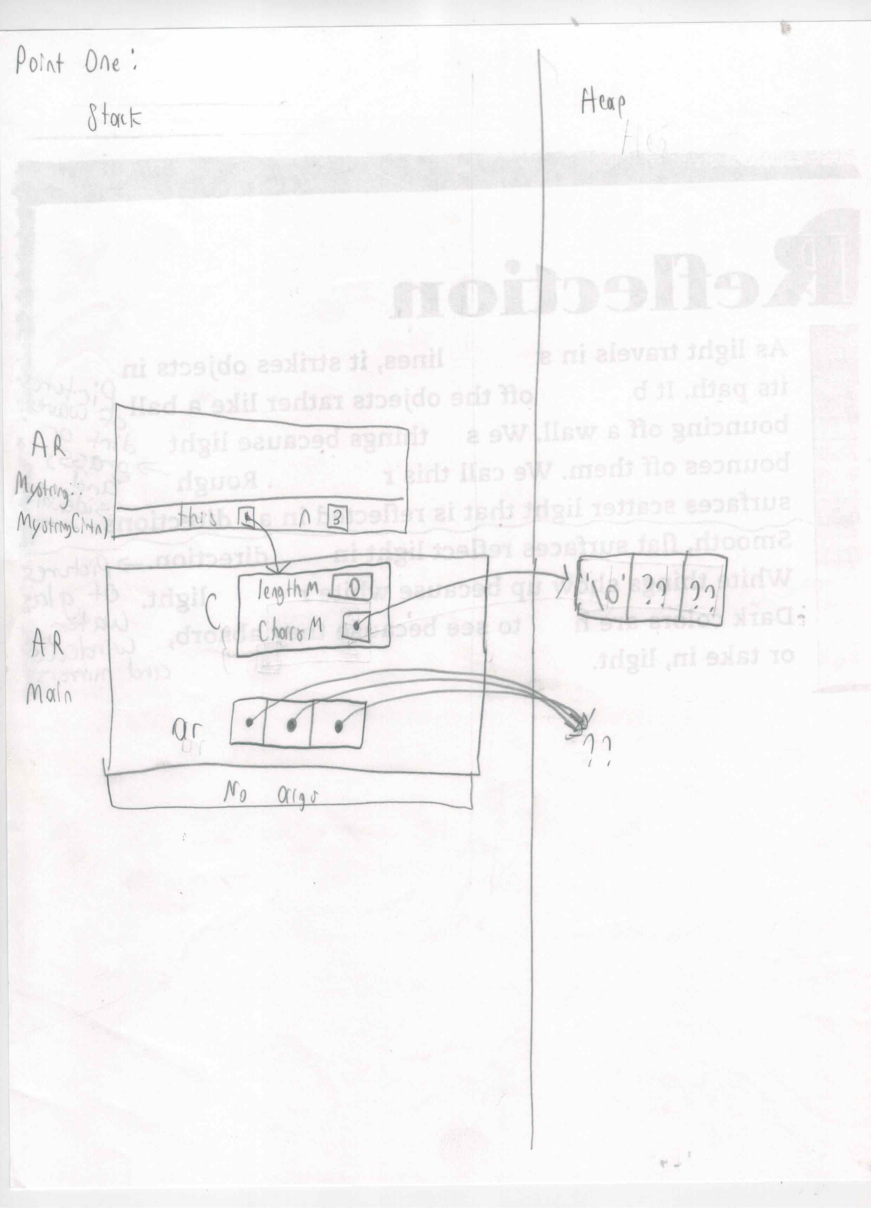

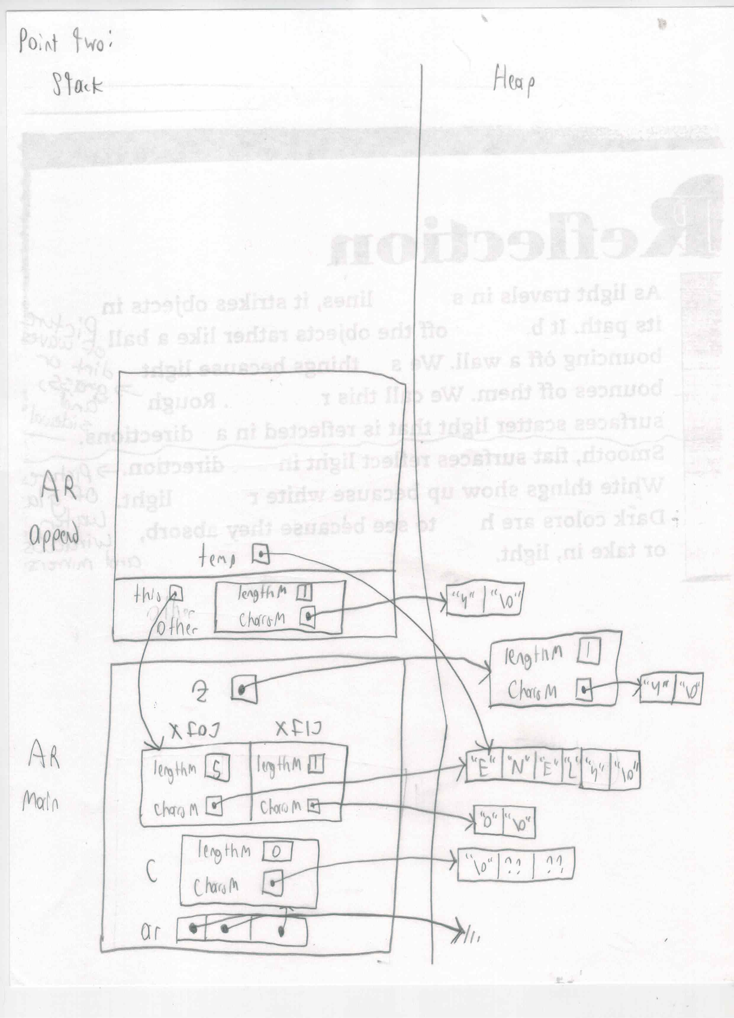

**Exercise B Part I**

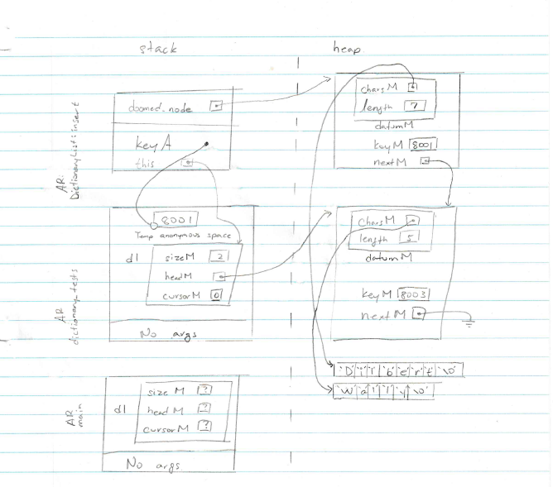

**Exercise B/C sample output**

